laughDB P02 Submission

1. Updated Abstract (Text in blue indicates update from abstract)

Project Name: laughDB

Categories: Media – Comedy

Names and NetIDs of the Students in the Team:
- Sam Friedman (srf83)
- Ariel Vilensky (apv28)
- Atkins Dube (akd74)

Project Description (text added after P01 shown in blue):
Our project is a comedy search engine that allows users to search for keywords, themes, or topics and retrieve relevant segments from comedians’ routines, stand-up specials, talk show appearances, and other performances. The system will also accept input in the form of humor types such as irony, dark humor, and similar categories.

For the output, the system will return approximately 5–10 matching results, each presented as a short paragraph containing transcript text from the performance. The primary sentence or phrase that matches the user’s query will be italicized, and the paragraph will include approximately 3–5 sentences before and after the match to provide context for the joke.

In addition to the paragraph, the system will display metadata including the comedy special from which the segment originates, the comedian’s name, and a link to watch the video of the performance when available. Additional features may include filters based on IMDb ratings of the comedy special.

Project Goals:
The target audience includes aspiring comedians who want to learn from well-known comedians’ routines, as well as comedy fans interested in revisiting performances they have seen or discovering new material from their favorite comedians or comedy themes. The goal is to make comedy performances searchable and easier to explore based on content, topics, and performers.

Information Retrieval Aspect:
Users will input keywords, themes, or comedian names describing the type of comedic content they are looking for. For example, a user might search for phrases such as “school bus jokes” or “jokes about Leonardo DiCaprio.”

The system will search through a corpus of stand-up comedy transcripts collected from ScrapsFromTheLoft, and potentially transcripts extracted from YouTube performances (this component is still tentative). It will then return a paragraph containing the most relevant transcript segments along with metadata such as the comedian, performance title, and potentially a link to the original video.

Relation to Prior Projects and Existing Apps:
Based on our review of previous projects and existing applications, there does not appear to be a direct equivalent to our idea. The closest example is HahaFactory, which focuses on searching for jokes, whereas our project focuses on searching full stand-up routines and performances.

Social Aspect:
This component is still a work in progress. Our initial plan is to incorporate IMDb ratings into the system by allowing users to filter search results based on the ratings of comedy specials, enabling them to prioritize highly rated performances.

2. TA Meeting, Application Evaluation and Comparison to Existing Systems

TA Meeting:
Our meeting with the TA helped us think more concretely about the next steps in our project. Our TA, Alisha, prompted us to consider potential irregularities in the dataset that might interfere with the retrieval results. While skimming through several transcripts, we noticed the presence of song lyrics, audio descriptions, and other non-comedic text that would likely introduce noise into the search results. As a result, we plan to implement preprocessing steps to remove these elements during the data cleaning stage.

Another important point raised during the meeting was clarifying exactly what our system would retrieve for the user. Initially, we had not fully specified the structure of the output. Through the discussion, we decided that instead of returning only a single matching sentence, the system would return a short paragraph centered around the matched segment, including several sentences before and after the relevant phrase. This allows the user to see the full context of the joke rather than a fragment that might not be meaningful on its own.

The TA also suggested that improving the user experience could help make our project more engaging. One simple idea was to design a distinctive logo and interface for the website to make the application feel more polished and unique.

Application Evaluation:
To evaluate our system, we plan to use both quantitative and qualitative methods. First, we will construct a set of example queries such as “school bus jokes,” “dark humor about celebrities,” or “Leonardo DiCaprio jokes.” For each query, members of the team will manually identify transcript segments that are relevant to the query. These will serve as our ground truth relevance judgments. We will then evaluate our retrieval system by measuring how many of the top results returned by the system are actually relevant. In particular, we will compute metrics such as precision at k (e.g., Precision@5 or Precision@10) to determine whether the system is successfully returning relevant comedy segments in the top results. We may also conduct user testing within our group or among classmates, asking them to judge whether the retrieved results match the intent of their queries. If the majority of the top-ranked results are relevant and users find the retrieved segments useful and entertaining, we will consider the system successful.

Comparison to Existing Systems:
Our project does not have a strong similarity to existing projects from previous offerings of the course. The closest example we found is HahaFactory, which focuses on searching for individual jokes. In contrast, our system searches through full stand-up comedy transcripts and retrieves segments from entire comedy specials. Our system also emphasizes contextual retrieval by returning surrounding sentences from the transcript, allowing users to experience the setup and punchline of the joke rather than isolated one-line jokes. Additionally, we plan to incorporate metadata such as comedian name, special title, and potentially IMDb ratings to allow users to filter and explore results in different ways. These aspects differentiate our project from existing joke-search systems and allow us to focus on a richer form of comedy content.

3. Data Description, Exploration and I/O Examples

Data Outline and Description:
Our dataset consists of transcripts of comedians’ routines from a variety of sources. These include full stand-up specials released on streaming platforms as well as comedy monologues performed at award shows and special events. For example, the dataset includes transcripts from specials such as Mike Epps: Ready to Sell Out (2024) on Netflix, as well as monologues performed at major events like Nikki Glaser’s opening monologue at the Golden Globes (2025). The dataset also contains performances from special political or entertainment events such as Trevor Noah at the White House Correspondents’ Dinner (2022).
Our current dataset contains 593 transcripts, spanning comedy performances from 1971 to 2025. This wide time range allows the corpus to capture multiple generations of comedic styles, topics, and cultural references.
Each transcript includes metadata describing the performance. This metadata typically contains information about the comedian, the director, and the release date of the special or event. For example, the transcript for Kevin Hart: Acting My Age (2025) includes the following metadata:
Kevin Hart: Acting My Age (2025)
Director: Leslie Small
Stars: Kevin Hart
Release date: November 24, 2025
In addition to metadata, the transcripts also include audio descriptions that capture audience reactions during the performance. These descriptions typically indicate when the audience laughs, cheers, or applauds and are written inside square brackets. For example:
[crowd laughing]
These cues help convey the atmosphere of the performance but may need to be removed or filtered during preprocessing, since they do not represent actual spoken dialogue.
Most importantly, each transcript contains the full spoken dialogue of the comedian’s routine. These transcripts capture the exact wording of jokes, stories, and punchlines delivered during the performance. For example, the transcript for Kevin Hart: Acting My Age contains passages such as the following:
Forty-five is different. All we talk about now is injuries and medicine. This is real shit. After 40, you stay hurt. I don’t know what it is, man. You stay hurt, but you just don’t know how it happened. Every conversation you have starts off with a question about an injury that you don’t know how it got there. “I fucked my goddamn neck up today.” “I don’t know what I did to my goddamn neck.” Everybody cares about your injury after 40. Everybody wanna help.
Passages like this illustrate how comedians frequently structure jokes around relatable life experiences, such as aging or everyday frustrations. These types of passages form the core searchable content that our information retrieval system will analyze and return when users submit queries.

Data Exploration:
To begin our data exploration, we considered the first 200 transcripts from our corpus. Since the full dataset contains approximately 593 transcripts, analyzing 200 transcripts represents over one-third of the entire corpus, which is sufficiently large to provide a representative overview of the dataset.
Our first objective was to identify the most common words in the transcripts and measure how frequently they appear. This allows us to determine which words are too common to be useful for retrieval, helping guide our decisions about term frequency filtering and stopword removal in later stages of the system.
Using a Python routine, we computed the top 15 most common words in the transcripts along with their frequencies. The results are shown in the chart below:
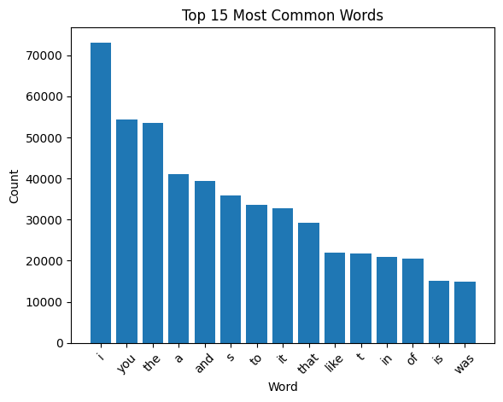

As expected, the most common word in the dataset is “I”, followed by “you” and “the.” Other frequent words include “it,” “that,” and “was.” These words commonly appear in everyday speech and largely consist of pronouns, filler words, and conversational connectors. Because stand-up comedy transcripts are derived from spoken language, it is not surprising that these types of words appear with very high frequency.
To reveal more meaningful terms, we filtered out standard stopwords as well as audio descriptions. After removing these words, the most common remaining terms included “like,” “know,” “don,” and “just.” However, these words are still extremely common in conversational speech and therefore may still dominate the corpus in ways that are not useful for information retrieval.
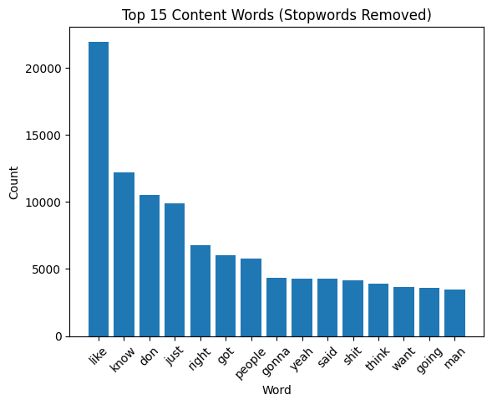
To better understand their impact, we computed the percentage of the entire corpus occupied by the most frequent remaining words. The resulting distribution is shown in the chart below.
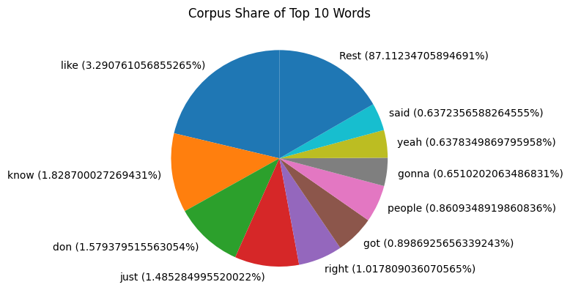
From this analysis, we observed that several words still occupy a significant proportion of the corpus, indicating that they remain overly dominant.
Based on this distribution, we applied an additional frequency filtering threshold, removing words that appear in more than 0.3% of the total corpus tokens. After applying this threshold, the remaining top terms reveal more content-bearing words that are more likely to capture meaningful topics in the transcripts.
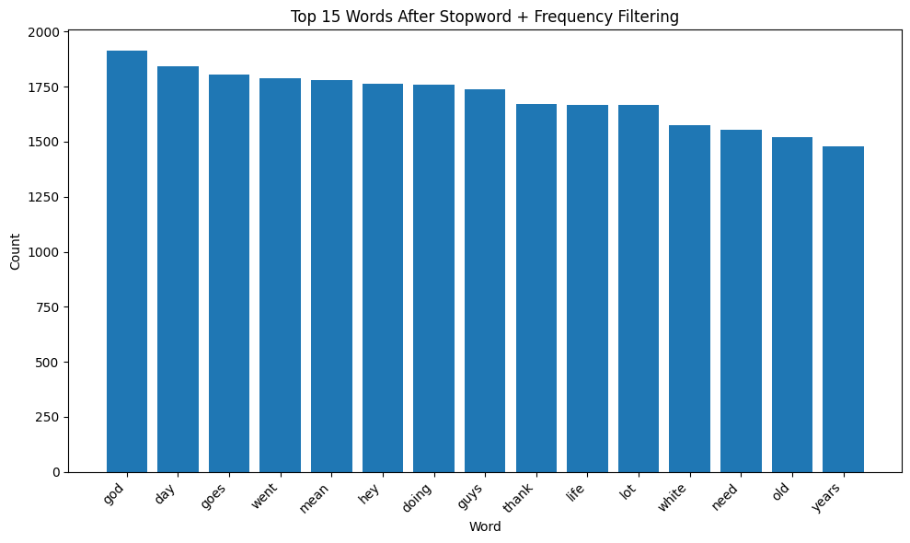
In addition to identifying overly common words, we also examined extremely rare words in the dataset. Words that appear only once or twice across the entire corpus are often not useful for retrieval and may instead represent names, transcription artifacts, or unusual phrases.
To analyze this phenomenon, we generated a bar chart showing examples of the least frequent words in the dataset. Examples include terms such as “osmond,” “sororities,” and “chinchillas,” each appearing exactly once. Because such words contribute little to retrieval performance and may introduce noise, these terms will also be filtered during preprocessing.
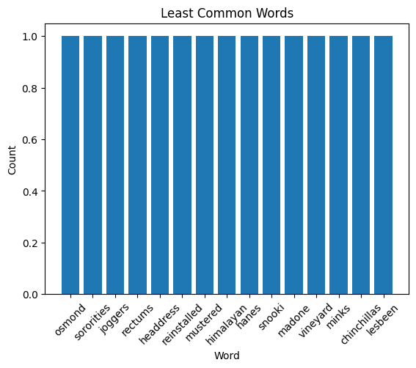
Another important aspect of our exploration is understanding which comedians appear most frequently in the dataset. Since some comedians have multiple specials in the corpus, it is useful to examine how transcripts are distributed across performers.
The chart below shows the number of transcripts associated with each comedian. From this visualization we observe that the most frequently represented comedians include Dave Chappelle, Kevin Hart, and Iliza Shlesinger, each appearing multiple times in the dataset.
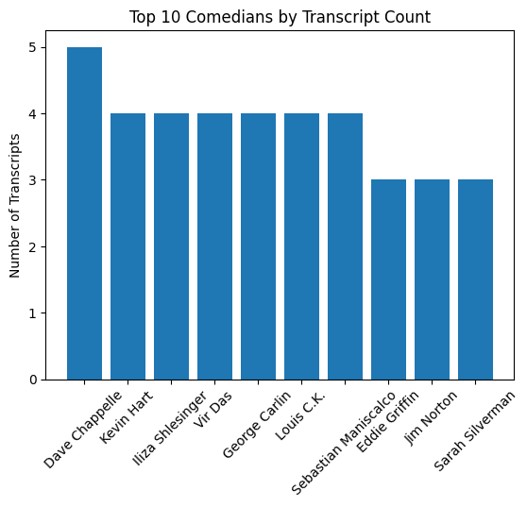
To further understand this distribution, we plotted a histogram of the distribution below and computed summary statistics describing the number of transcripts per comedian. Specifically, we calculated the mean and median fraction of transcripts associated with each comedian. The mean fraction of transcripts per comedian is 0.0066, while the median fraction is 0.005. These values indicate that most comedians appear only a small number of times, while a few performers contribute multiple specials to the corpus.
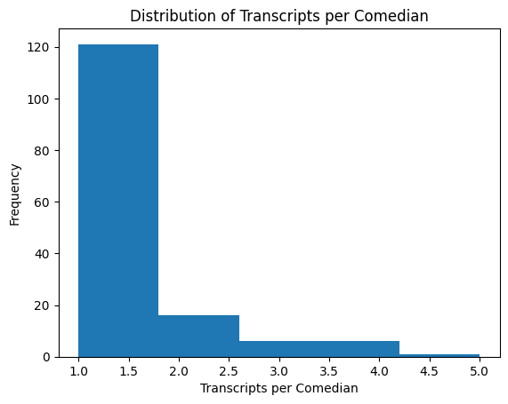
Anticipated Challenges:
From a system design perspective, one challenge we anticipate is matching the sentiment or style of humor in a user’s query to relevant transcript segments. For example, a user searching for “dark humor” may not necessarily use words that appear directly in the transcript. Searching for the word dark alone may not produce meaningful results. Instead, jokes that fit this category may involve topics such as misfortune, illness, death, or taboo subjects. To address this challenge, we may use word embeddings or semantic representations, which we learned about in class, so that the retrieval system can identify passages that are semantically related even if they do not contain the exact query terms.

Another challenge raised during our TA meeting concerns memory constraints. Our current dataset is stored as a large JSON dictionary containing all transcripts, and the size of this structure may be too large for the hosting environment used for the system. If this becomes a limitation, we may need to reduce the number of transcripts included in the corpus or restructure the data storage approach. While reducing the dataset would decrease memory requirements, it may also limit the expressive power of the retrieval system, since fewer transcripts would be available for searching.

I/O Examples:
Our system will take a natural-language comedy query and return the most relevant transcript snippets from our Scraps From the Loft corpus, along with a small amount of surrounding context so that the result is interpretable.
For example, one good query is “old age jokes”. This is a good query because it clearly expresses a specific comedic theme that is likely to appear in stand-up transcripts. Many comedians frequently joke about aging, physical decline, generational differences, and life milestones, making this a realistic and meaningful information need. The query also contains enough semantic information for a retrieval system to identify relevant passages discussing getting older, rather than simply matching individual keywords like “old” or “age.”
For the aforementioned query, a good output would be a snippet from Kevin Hart: Acting My Age (2025 )such as:
He’s gotta be a fucking Avenger. I ain’t never seen no better knees. What kind of knees does my son have? I go down the stairs sideways. The older you get, they change, right here. [crowd laughing] … It’s too easy to get hurt. I stepped in the shower the other day. My leg got away from me.
In this excerpt, the transcript clearly references getting older and the physical effects of aging, such as difficulty moving or walking down stairs. The humor is explicitly built around aging, making it a strong match for the user’s query.
Another good output would be this excerpt from Ricky Gervais: Mortality (2025):
I wanna tell you some of the things I’ve learned, what it’s like to be me at this age, ’cause I’m getting old now… The good thing about getting old is you don’t care what people think about you. Well, you should care a bit, because caring what people think about you is what stops you walking around with shit down your trousers.
This excerpt clearly matches the intent of the query because the comedian directly discusses getting older and social perceptions of aging, turning those observations into a joke.
However, even within a relevant transcript like Mortality, a bad output could still be retrieved. For example:
But I’m, um… I’m too old now not to say what I want. You know? I wanna say and do what I want all the time. I wanna do my favorite thing all the time. I don’t even like doing my second favorite thing if I think I could be doing my favorite thing, you know? My favorite thing is play tennis. I play every Friday. I keep Fridays free. I look forward to it. I play tennis. It sets me up for the week. So if ever on a Friday I have to do my second favorite thing, like three weeks ago, attend a neighbor’s kid’s funeral, I’m like… [laughter] “This is boring.” [laughter] But we all want respect, right? We all want respect, and we all wanna raise our status in society. We can’t help that. That’s in our evolution.
This output would be poor for two reasons. First, it is extremely long, which could overwhelm the user and make it difficult to identify the relevant joke. Second, although it briefly mentions age at the beginning, most of the excerpt shifts to topics like social media and virtue signaling, which are unrelated to the user’s information need.
Another bad output for the query “old age jokes” would be a segment from Anthony Jeselnik: Bones and All (2024):
…I was doing a show in Alabama. Told them that joke. Guy in the audience stands up and says, “Anthony, I hate to break it to you, but the age of consent in Alabama is 16, so you gotta change that.” [audience chuckles] I said, “Oh, yeah?” You got to change that. And then a couple of weeks later, I did a show in Mississippi. Told them that joke then told them about Alabama. [audience chuckles] Guy in the audience stands up and says, “In Mississippi, the age of consent is 14.” And I said, “Ho-ly shit.” [audience laughs] That’s perfect.
Although this passage contains the word “age,” it refers to legal age rather than aging, which is not what the user intended. This demonstrates how a system relying purely on keyword matching could return irrelevant results.
A similar issue appears with this excerpt from Jared Freid: 37 and Single (2023):
She had old tweets come out. She got fired from Teen Vogue because old tweets were found by Gen Z kids.
While this passage contains the words “old” and “age,” they refer to old tweets rather than aging itself, so the semantic meaning does not match the user’s query.
Another useful query is “dating in your 30s” (or “being single in your late 30s.”) The query “dating in your 30s” is also a strong query because it targets a well-defined life experience that comedians often discuss in stand-up routines. The phrase combines both a topic (dating) and a life stage (being in one’s 30s), allowing the system to retrieve jokes about relationships, dating apps, or social expectations at that age. Since the query reflects a clear and relatable theme, it provides enough context for the system to identify relevant transcript segments and avoid unrelated matches that merely contain the number “30.”
For “dating in your 30’s”, a good output would be an excerpt from Jared Freid: 37 and Single (2023):
I’m 37 and single. It’s a bad combination. I’ve gotten pickier… I was on a dating app, said no to someone’s name the other day… I’m not dating a Darlene.I’m not a husband from the 1950s. I’m not… dating the Werther’s Originals of names. I’m not dating a Sophia, a Blanche, a Rose, a Dorothy. If your name was on Nick at Nite, I’m not dating you.
This passage directly addresses dating experiences while being single at age 37, making it highly relevant to the query.
However, a bad output could occur if the system returned an excerpt that was too short, such as:
One woman, her profile said, “I like to wake up and read and go for a walk with my morning coffee.” My guttural, 37-year-old reaction to that was, “Fuck off.”
Although this line references being 37 and reacting to a dating profile, the snippet is too short for the user to understand the context or the full joke. This highlights why our system must return several surrounding sentences to provide adequate context.
A better output would therefore include additional context:
It’s me. I’m the issue in all of this… One woman, her profile said, “I like to wake up and read and go for a walk with my morning coffee.” My guttural, 37-year-old reaction to that was, “Fuck off.” I knew everything about her from that sentence. I knew the book. I knew the coffee. I knew the walk. Fuck that book about a missing woman. Fuck that book.
Providing this additional context allows the user to understand the setup and punchline, making the result more informative.
Another bad output for the query “dating in your 30s” could come from Gary Gulman: Born on 3rd Base (2023):
They spelled summer with a dollar sign… $30 for the shorts. How much for the whimsy?
This excerpt contains the number 30, but it refers to money rather than age, making it irrelevant to the query. This example highlights another engineering challenge: distinguishing between numeric matches
Examples of Good and Bad Queries:
Good Queries:
1. “old age jokes”
This is a good query because it expresses a clear comedic theme. Many comedians joke about aging, physical decline, or getting older, making it likely that relevant transcript passages exist in the dataset.
2. “dating in your 30s”
This query combines a topic (dating) with a life stage (being in your 30s). This makes the user’s intent clear and allows the system to retrieve jokes specifically about relationships and dating experiences later in life.
3. “jokes about social media”
This is a good query because social media is a common topic in modern stand-up comedy. Many transcripts include jokes about Twitter, Instagram, or online culture, making it easy for the system to find relevant segments.
4. “parenting jokes”
This query describes a specific theme that frequently appears in comedy specials. Many comedians discuss raising children or family life, which increases the likelihood of retrieving meaningful results.
5. “airport travel jokes”
Travel frustrations, airports, and airlines are common observational comedy topics. The query clearly specifies the context, making it easier to retrieve relevant comedic segments.
Bad Queries:
1. “funny”
This query is too vague. Nearly every transcript in the dataset is intended to be funny, so the system would struggle to determine which passages best satisfy the user’s information need.
2. “good jokes”
This query is subjective and unclear. What counts as a “good” joke varies from person to person, so the system cannot reliably determine relevance.
3. “30”
This query is ambiguous. The number could refer to age, money, time, or other unrelated contexts, making it difficult for the system to retrieve meaningful results.
4. “age”
This query is overly broad. The word “age” could refer to aging, legal age, historical time periods, or many other contexts, which may lead to irrelevant results.
5. “jokes about a 37-year-old man using a dating app on a Tuesday night in New York”
This is a poor query because it is too specific and overly detailed. A transcript might contain some of these words (e.g., “37,” “dating,” or “New York”) in unrelated contexts, which could cause the system to retrieve passages that only partially match the query.

